The BLX Global FAANG Revenue Index provides the only pure play exposure to revenue growth of the “FAANG” Stocks: Facebook, Apple, Amazon, Netflix and Google. Priced daily based on trailing twelve month revenue for index components as reported in SEC filings. With a product license, fund sponsors may create ETNs, derivatives, swaps, one-off structured notes, and other OTC products whose underlying constituents or performance are linked to the value of this index.

|  |  |
| --- | --- |
| **Annual Return** | |
| YTD | 17.1% |
| 2019 | 12.0% |
| 2018 | 26.1% |
| 2017 | 17.3% |
| 2016 | 7.7% |
| 2015 | 21.7% |

Investors interested in licensing the index should send inquiries to [sales@blxglobal.com](mailto:sales@blxglobal.com)

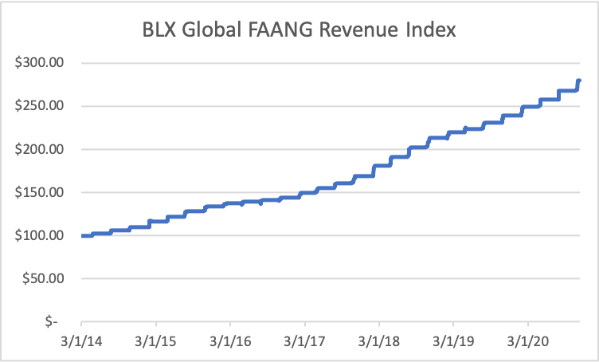

|  |  |  |  |  |  |  |
| --- | --- | --- | --- | --- | --- | --- |
| **Index Performance - Total Return** | | | *Annualized* | | | |
|  | 1 Month | 3 Month | 1 Year | 3 Year | 5 Year | Since Inception |
| BLX Global FAANG Revenue Index | 4.4% | 4.4% | 17.4% | 18.3% | 15.9% | 16.6% |

|  |  |  |  |  |
| --- | --- | --- | --- | --- |
| **Key Facts** | |  | **Risk and Return Characteristics** | |
| **Reuters Ticker Symbol** | .BLXGLFAANGR |  | **Standard Deviation** | 0.36% |
| **Inception Date** | March 3, 3014 |  | **% Up Days** | 6.5% |
| **Base Value** | $100 |  | **% Down Days** | 0.4% |
| **Index Calculation** | Daily |  | **% Days Unchanged** | 93.0% |
|  |  |  |  |  |

Disclaimer

*Nothing in this document is an offer or solicitation to sell or purchase any security. It not possible to invest directly in an index. Index performance does not reflect the deduction of any fees or expenses. Past performance is no guarantee of future results. BLX Global does not sponsor, endorse, sell, or promote any investment product linked to or based on the Index. BLX Global shall have no liability for any errors or omissions in the calculation of the index.*